2026 Season Pass Information Sheet

Name__________________________________________________ Date ______________

Family (Spouse & kids) ________________________________________________________________

Mailing Address ______________________________________________________________________

City ________________________________ ___ State _____________ Zip ________________

Phone ____________________________ Email ___________________________________________

Early Pay (By March 1) Regular (after March 1)
Single Value * $1,650 $1,850 _____________
Single Regular $2,000 $2,200 _____________
Young Adult ** $1,500 $1,700 _____________

Couple Value * $2,250 $2,550 _____________
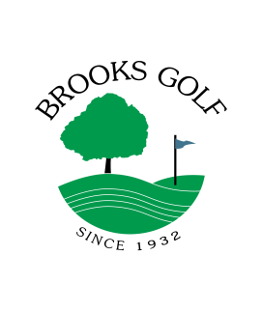
Couple Regular $2,550 $2,850 _____________
Family Value * $2,350 $2,650 _____________
Family Regular $2,750 $3,050 _____________

Additional Cash or Check Discount if paid by March 1 -$100 _____________

Subtotal _____________

Add 7% Sales Tax _____________

Total Due _____________

Payments can be mailed to: Brooks Golf, PO Box 678, Okoboji, IA 51355
If paying by credit card, we accept Visa, MasterCard, Discover and American Express

Type of Card: Visa _____ MasterCard _____ Discover _____ American Express _____
Card Number ___________________________ Expiration ________ Security Code _______
Signature ___________________________________ _______ Date ______________

We offer a payment plan that allows payment of dues over a period of time subject to the following conditions:
1. Join by March 1 with first payment
2. You agree to pay remaining balance in 3 equal monthly installments on the 1st of April, May & June. We keep your card on file and bill your installments automatically

Yes, I would like to enroll in the payment plan. Please bill my credit card monthly so balance is paid in full June 1
Signature ______________________________________ Date ________________

Note: * Value Passes are Limited to golf after 2:30 pm, Monday through Saturday and after 12 noon on Sunday
** To verify under 35 young adult, please attach a photocopy of your drivers license

Family Passes include kids in household under 21, must be 16 to drive cart
Season Passes include 50 buckets of balls loaded on a card. Additional buckets can be purchased at 50% off

Corporate Options are available. Please contact us to discuss a custom package for your business.

